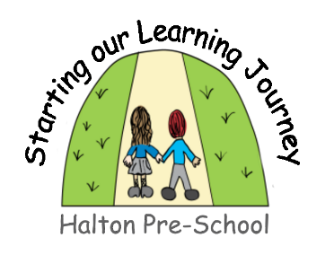

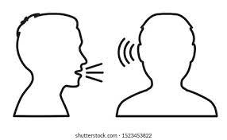

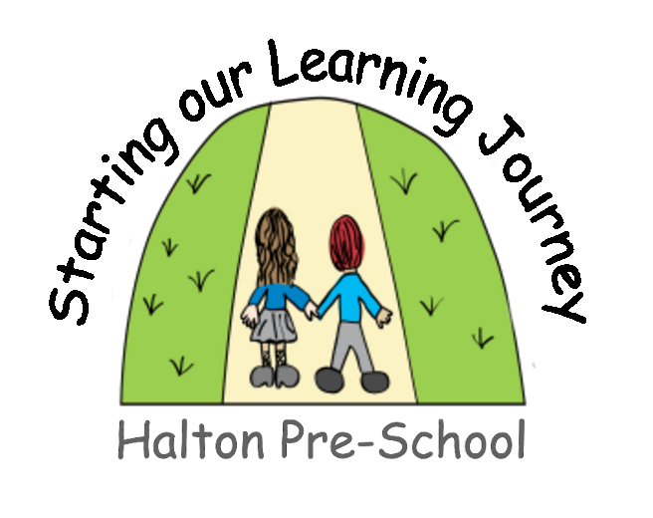
Fine motor skills- Playdough, threading, mark making for a purpose
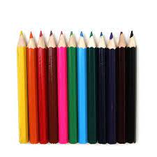

Nursery rhymes
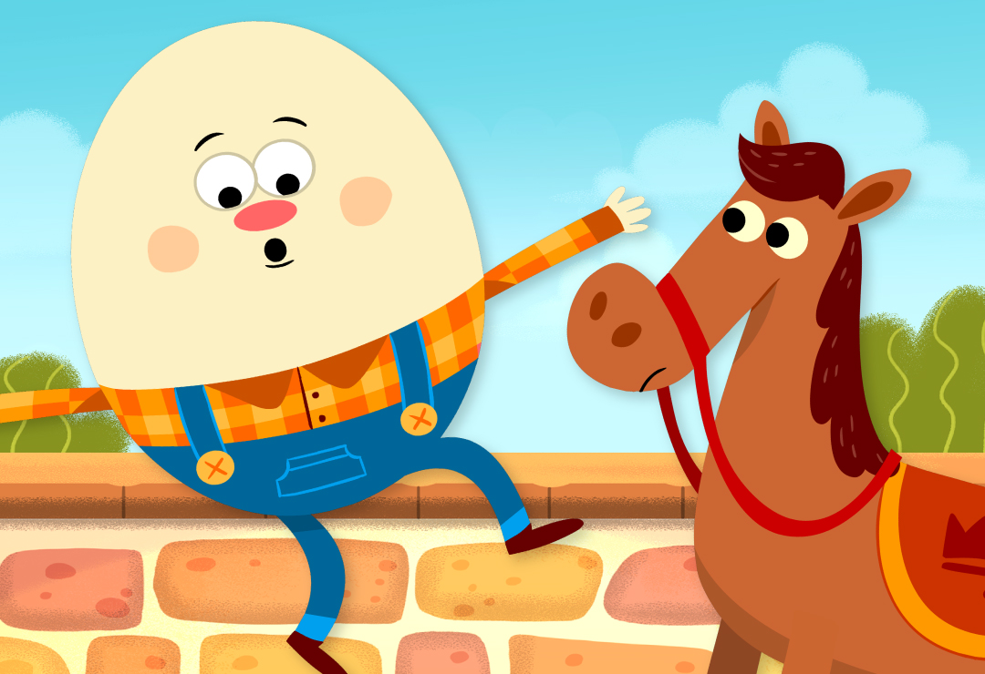
What comes before Phonics

Language play- I spy, board games

Books- story books and picture books
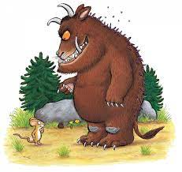
A variety of print- magazines, newspapers, digital words, labels, shops signs, logos, words in their environment

Spoken language- an environment with lots of conversation, chatting, interaction and listening

Oral blending- turn on the t-a-p, shut the d-oor

Oral segmenting- c-a-t cat

Initial sounds- in name ‘H H Harry’, in spoken words ‘D D Dog’

Role play- dressing up, teddy bears picnic, dolls house, dinosaurs, trains and cars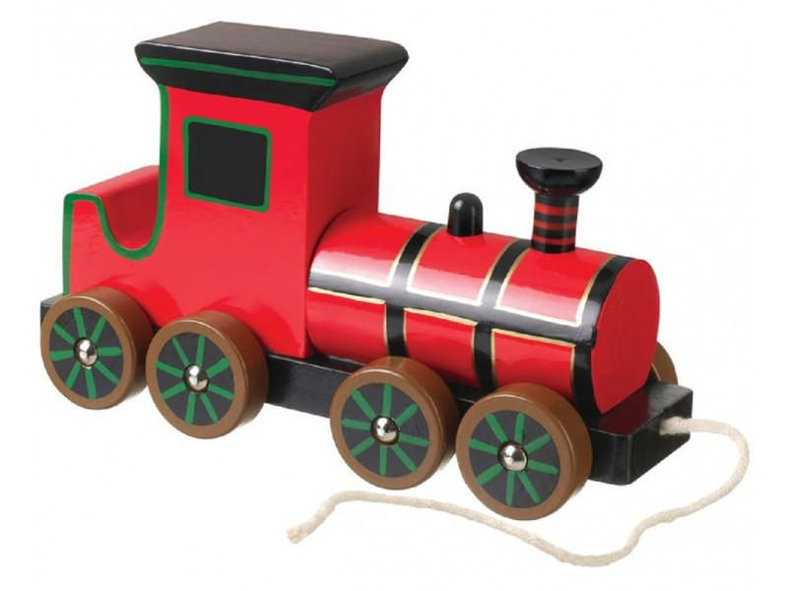

Gross motor skills- balancing, dancing, getting dressed and undressed, marching, blowing bubbles, playing catch

Responding to sounds in the environment

